**Team Members:**

Roshini Varada- 26

V H N V R S Sai Pavan -27

**Introduction:**

To design a system to signup and login using ionic framework which uses image search API

**Objective**

To design a login and signup page using ionic framework.

**Softwares Used:**

Visual Studio Code, Ionic Framework

**Technologies Used:**

Angular 8, Ionic Framework

**Design/Implementation:**

User can be signed up by putting the details in the local storage in the register page and the user can be authenticated in the login page by getting the same details

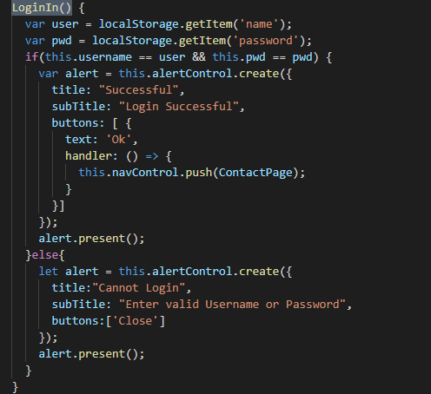

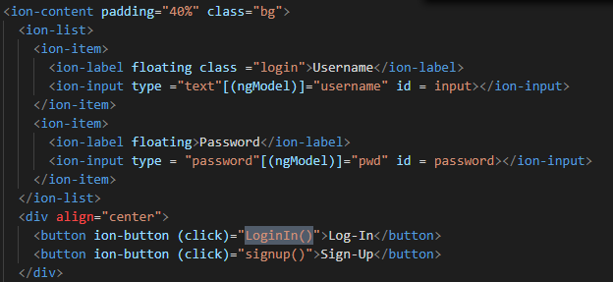

**Loginmethod call**

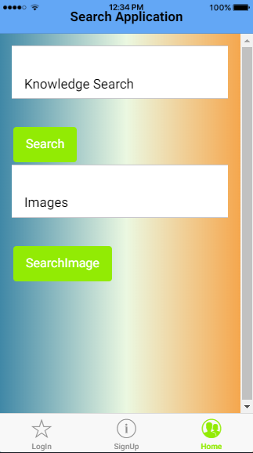

**Home screen**

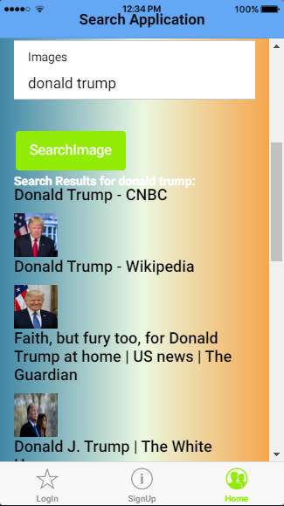

**Image search**

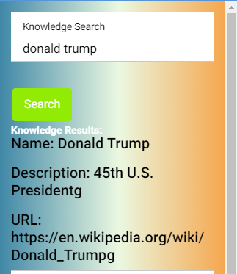

**Knowledge Search**

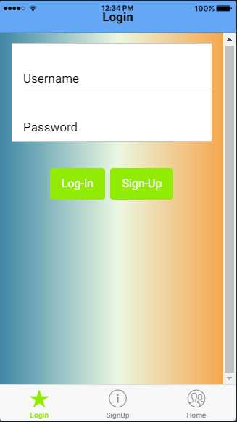

**Ios login**

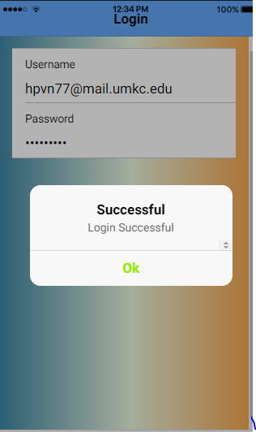

**Login success**

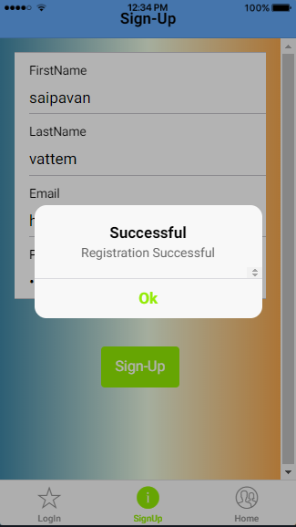

**Registration success**

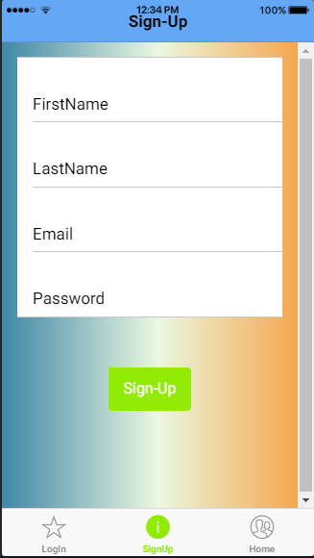

**Signup**

**Conclusion:**

From this experiment we will be able to know to design an app in ionic framework for bot android and IOS.